- Residential Aged Care Facilities (RACF)Our Region
- Links
Moyne Health Services accommodation options
Moyne Health Services has been caring for Port Fairy and district residents for more than 100 years. We have two distinctive homes Belfast House/Moyneyana House tailored to suite a variety of individual needs. All of our services are co-located within a complex that provides a range of medical and other programs, including:

- General medical practice –directly adjacent to our homes
- X-Ray Services
- Pathology Services
- 24-hour Registered Nurses
- Allied Health Care professionals
- Urgent and Acute care in our hospital
- Leisure and Lifestyle programs

In addition to ready access to these services, our residents enjoy nutritious and seasonal freshly cooked meals, all of which are prepared on the premises daily.

Being social at Moyne Health Services
Moyne Health Services has an active philosophy of encouraging a high quality of life. This includes providing spaces and places for communal living and social interaction for all our residents to enjoy.
We work hard to create a home-style atmosphere in which residents feel a sense of belonging.
To that end, all residents have ready access to our activity rooms, spacious dining and living rooms and large entertainment areas. A sun-filled conservatory is located at the heart of our facility
Accommodation options include:
• Belfast Premium suites
• Belfast Deluxe suites
• Belfast Classic suites

• Moyneyana Premium suites
• Moyneyana Deluxe suites
• Moyneyana Classic suites

Belfast House

Regent Street, Port Fairy VIC 3284
Year facility was built: 1996
Year facility was most recently refurbished: 2019
Belfast House is a 30 bed home, surrounded by home -style like furnishings boasting spacious rooms with an abundance of natural light and picturesque cottage gardens. Belfast House offers a quieter relaxing atmosphere, ideal for couples and those who prefer the quieter lifestyle.

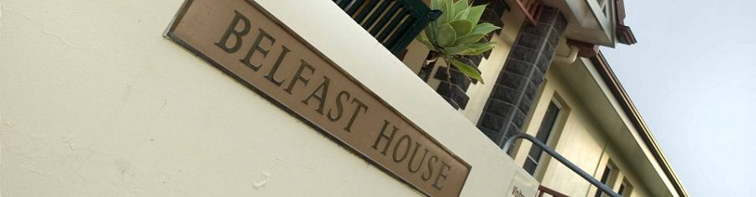

MAXIMUM accommodation prices.
Residential Accommodation Deposit (RAD) Daily Accommodation Payment (DAP)

Premium Rooms
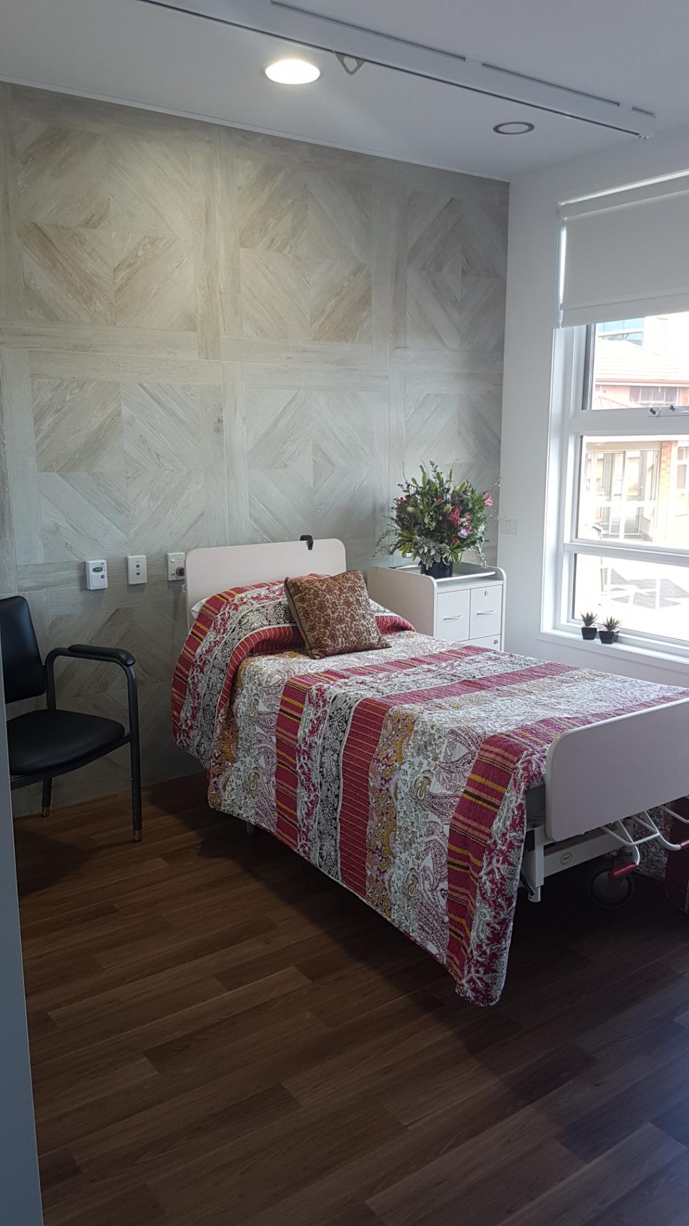
Newly refurbished, these single suites offer plenty of natural light and have contemporary furnishings and décor. Each suite has a private spacious ensuite. Individual temperature controlled air conditioning. Decorated in modern neutral tones allowing a personal touch.

Deluxe Room
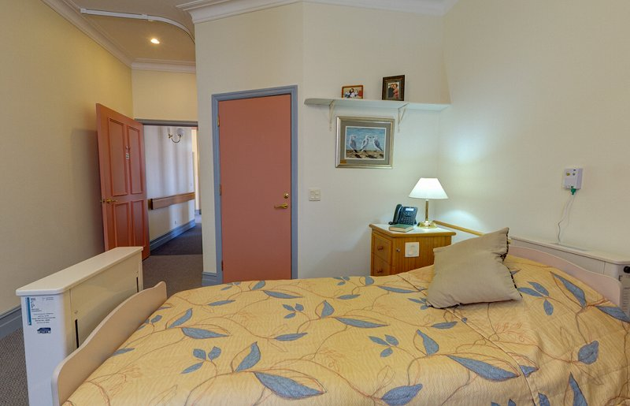
Large windows let in plenty of sunshine and light and each single suite has a private ensuite bathroom and heating. Tasteful furnishings and space provide a relaxed atmosphere.
Classic Room
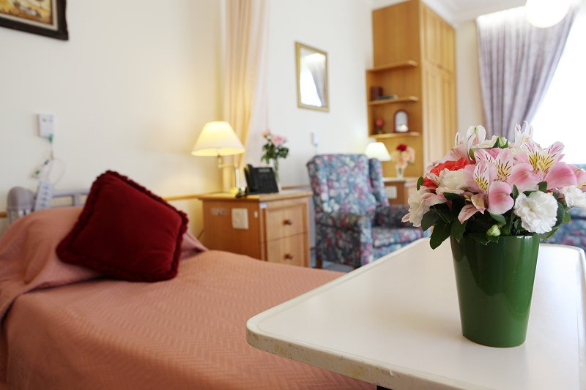
Our Classic shared suites provide accommodation for singles and couples. With private ensuites and home-style décor, these rooms are comfortable and well appointed. Residents are encouraged to personalise their rooms with their own belongings.

MAXIMUM accommodation prices.
Room Types | Residential Accommodation Deposit (RAD) | Daily Accommodation Payment (DAP)
Single Room – Private Ensuite (Premium) | $475,000 | $52.31 per day
Single Room – Private Ensuite (Deluxe) | $450,000 | $49.56 per day
Double Room – Private Ensuite (Classic) | $200,000 | $22.02 per day

Example of paying a combination of a 50%RAD and 50%DAP:
Room Types | Residential Accommodation Deposit (RAD) 50% | Daily Accommodation Payment (DAP) 50%
Single Room – Private Ensuite (Premium) | $237,500 | $26.15 per day
Single Room – Private Ensuite (Deluxe) | $225,000 | $24.78 per day
Double Room – Private Ensuite (Classic) | $100,000 | $11.01 per day

Number and Type of Bedrooms:
Room Type | Number of Rooms
Single Room With ensuite | 22
Double Room with ensuite | 4

Common Areas:
 | Dining Room | Lounge Room | Activities Room | Outdoor Areas
Number | 1 | 2 | 1 | 2

Bedroom Furnishings (supplied) | Y/N
Bed / mattress | Yes
Overbed table | Yes
Bedside drawers (locked / not locked) | Yes
Wardrobe | Yes
Linen | Yes
Television
In room | Resident to supply
Communal | Yes
IT
Phone | Yes
Virtual visiting | Yes
Internet | Yes
Resident computer access | Yes

Other Onsite Services:
Personal Services
Hairdressing | Yes
Full Hotel Services | Yes
Mail | Yes
Newspapers / magazines | Resident to Supply
Personal shopping | Yes
Personal laundry | Yes
Mobile voting | Yes
Visiting hours | Flexible visiting
Access to multi taxi program | Yes
Activities Programs | Yes
Food Services
Menu selection | Yes
Medical & other Services (onsite)
Pathology | Yes
Reflexology | No
Hydrotherapy Spa | No
Dementia Specific Programs | Yes
Pharmacy | Yes
Emergency Department | Yes
Radiology | Yes
Subacute programs | No
Dental services | No
Nail Therapist | No
Aromatherapy | Yes
Hearing services | Yes
Vision services | Yes
Allied Health | Yes
Visiting GPs/ frequency | Yes as required
Visiting medical specialists | Yes as required
School visiting program | Yes
Community Services
Church visiting program | Yes
Visiting Pets | Yes
Library | Yes

Moyneyana House
College Street, Port Fairy VIC 3284
Year facility was built: 1987
Year facility was most recently refurbished: 2020

Moyneyana House is a 52 bed home regarded as the social hub here at Moyne Health Services. Moyneyana House offers a variety of communual living and meeting areas surrounded by natural country charm gardens.
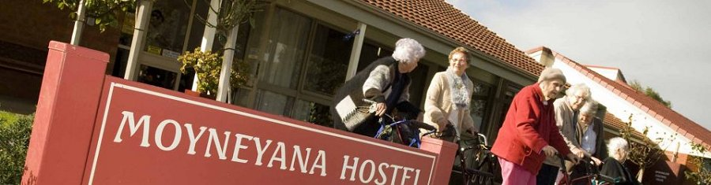

Moyneyana Premium Suites

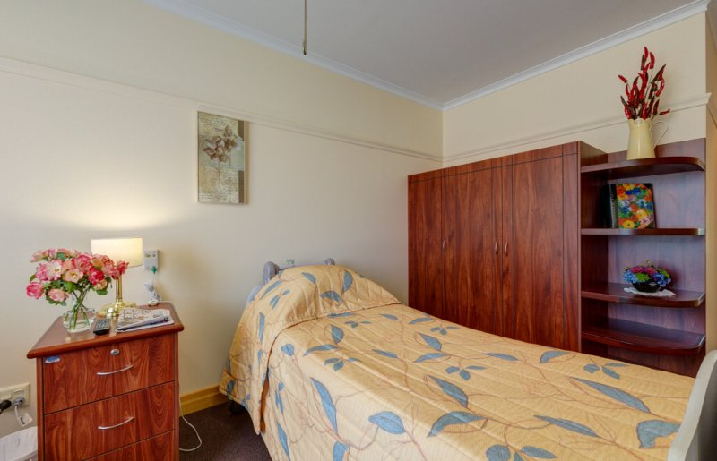
These large open contemporary rooms provide an abundance of space with large windows to fill the rooms with natural light. Many of the rooms are north-facing have high ceilings and spacious wardrobes.
Each premium suite has a private ensuite bathroom and easy access to communal living areas.
The premiums suites are tastefully designed and decorated, with plenty of opportunity for residents to add their personal touches. Window coverings are provided and all rooms are carpeted and individually heated.

Moyneyana Deluxe Rooms

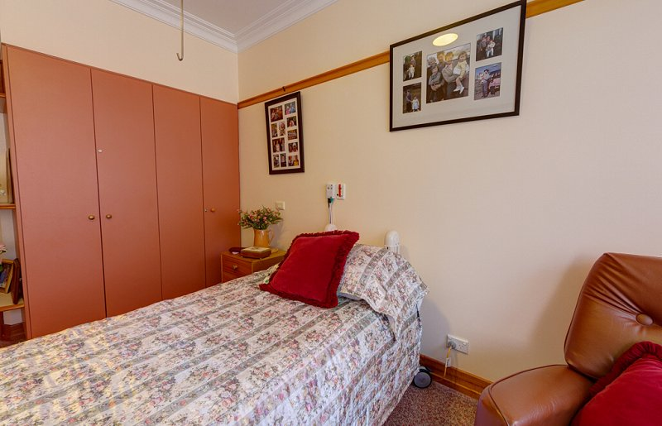
Located close to the sun-drenched conservatory, these suites are comfortable and well appointed. Some furniture is provided, but residents are encouraged to make their space their own with their own belongings. The interior design draws on soft colour palettes and stylish soft furnishings. The deluxe suites also have private ensuite bathrooms and individual heating.

Moyneyana Standard Rooms
Need updated photo with new refurbished rooms
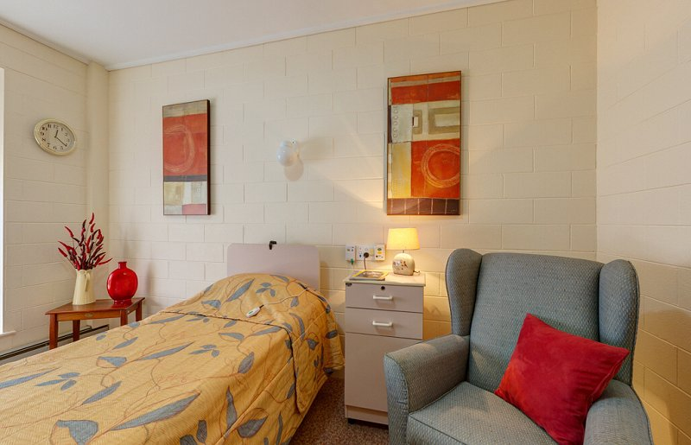
Our Standard suites are comfortable and well appointed. Private ensuite bathrooms and tasteful furnishings set the scene for relaxed, home-style accommodation within easy reach of spacious communal living spaces and activity areas. (will need to update with comments pertaining to refurbished rooms)

MAXIMUM accommodation prices.
 | Residential Accommodation Deposit (RAD) | Daily Accommodation Payment (DAP)
Single Room – Private Ensuite (Premium) | $550,000 | $60.57 per day
Single Room – Private Ensuite (Deluxe) | $450,000 | $49.56 per day
Single Room – Private Ensuite (Standard) | $400,000 | $44.05 per day

Example of paying a combination of 50%RAD and 50%DAP:
 | Residential Accommodation Deposit (RAD) 50% | Daily Accommodation Payment (DAP) 50%
Single Room – Private Ensuite (Premium) | $275,000 | $30.28 per day

Single Room – Private Ensuite (Deluxe) | $225,000 | $24.78 per day
Single Room – Private Ensuite (Standard) | $200,000 | $22.02 per day

Number and Type of Bedrooms:
Room Type | Number of Rooms
Single Room With ensuite | 52

Common Areas:
 | Dining Room | Lounge Room | Activities Room | Outdoor Areas
Number | 2 | 4 | 1 | 5

List of Services available to residents:
Bedroom Furnishings (supplied) | Y/N
Bed / mattress | Yes
Overbed table | Yes
Bedside drawers (locked / not locked) | Yes
Wardrobe | Yes
Linen | Yes
Television
In room | Resident to supply
Communal | Yes
IT
Phone | Yes
Virtual visiting | Yes
Internet | Yes

Resident computer access | Yes

Other Onsite Services:
Personal Services
Hairdressing | Yes
Full Hotel Services | Yes
Mail | Yes
Newspapers / magazines | Resident to Supply
Personal shopping | Yes
Personal laundry | Yes
Mobile voting | Yes
Visiting hours | Flexible visiting
Access to multi taxi program | Yes
Activities Programs | Yes
Food Services
Menu selection | Yes
Medical & other Services (onsite)
Pathology | Yes
Reflexology | No
Aromatherapy | Yes
Hydrotherapy Spa | No
Dementia Specific Programs | Yes
Pharmacy | Yes
Emergency Department | Yes

Radiology | Yes
Subacute programs | No
Dental services | No
Nail Therapist | No
Hearing services | Yes
Vision services | Yes
Allied Health | Yes
Visiting GPs/ frequency | Yes as required
Visiting medical specialists | Yes as required
Community services
School visiting program | Yes
Church visiting program | Yes
Visiting Pets | Yes
Library | Yes
Other (specify):

Our information guide explains our services within our aged care homes.
Link to brochure
https://swarh2.com.au/media/MHS%20Resident%20Admission%20Guide%20Brochure.pdf

Contact Us
We welcome all new enquiries regarding our aged care homes and can guide you throughout the entry process for both respite and permanent care.
If you would like further information, please contact our Placement Services Manager;

Phone: (03) 55680179 or (03) 55680100
Email: rross@moynehealth.vic.gov.au or reception@moynehealth.vic.gov.au

Further detailed information is also available on the My Aged Care Website
www.myaged care.gov.au
https://www.myagedcare.gov.au/aged-care-homes

